What happened over the summer?

Piscataway Councilwoman Chanelle McCullum was instrumental in connecting Verizon Wireless employees with students at Randolphville School. The Verizon staff collected school supplies that were presented to Randolphville principal Dr. Avi Slivko (r.). The donations were presented by (l. to r.) Janet Kerrigan, senior analyst at Verizon; Klesta Lamaj, executive assistant, and Kevin Treney, coordinator of Verizon's Health and Wellness Center. Verizon's Dina Albanese was also key to the employee collection effort.

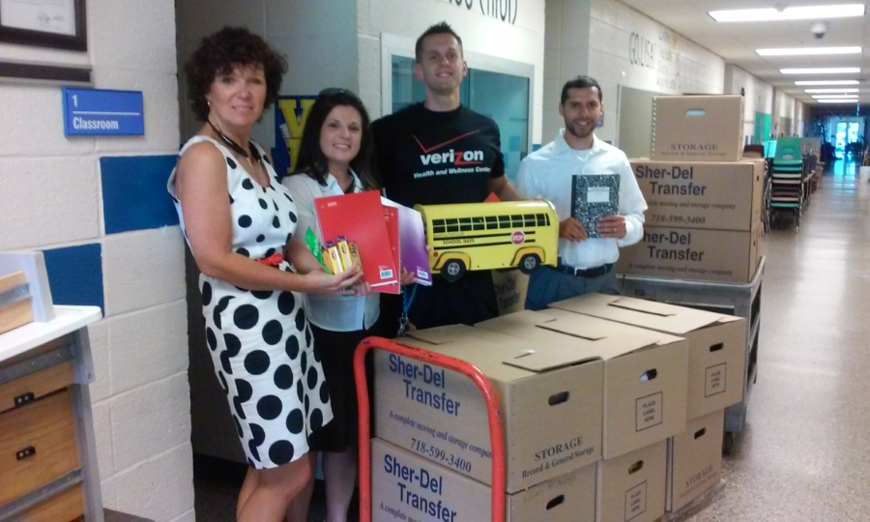

Jonathan Buggey, phys ed teacher at Piscataway High School, and head coach of Piscataway's Special Olympics track and field team, has been invited to be an assistant coach for Team USA at the 2015 World Special Olympics in Los Angeles. Mr. Buggey will attend a coach training camp at Purdue University prior to the world games. This year he led Piscataway's team to the state and national Special Olympic competitions. Mr. Buggey and his coaching staff are all volunteers.

Kyle Gurkovich, Quibbletown math teacher, set an official Guinness world book record for the highest number of pull-ups in 24 hours. Mr. Gurkovich had accepted the pull-up challenge as a fundraiser for former Quibbletown student Daniel Nols. The teacher was featured on Fox and Friends, a morning news show.

Piscataway High School's mentoring program, 50 Strong, will be presented at the National Mentoring Summit in Washington, D.C., this January. The program is run by L-Mani Viney, PHS social studies teacher and member of the national Board of Directors of Big Brothers-Big Sisters

